HEC REPORT SEPTEMBER 2011

Contents
Executive summary 1
PoP to PoP analysis 1
Intra Region PoP performance 4
Inter Region PoP to region Analysis 4
Comparison of performance of all inter region PoP to Region network: 9
Outliers 10
Outliers in Islamabad region 10
Outliers in Karachi region 10
Outliers in Lahore region 11
Outliers in Peshawar region 11
Outliers in Quetta region 11
Faisalabad PoP 12
Conclusion 12

Executive summary
All the traffic from all of the regions goes through Islamabad routers due to which performance of all of Islamabad region is degraded due to high traffic. As a result, round trip time of all of the nodes in all of the regions increases. Faisalabad PoP faced high RTT, IPDV and Losses because it goes through a router in Islamabad which takes long time. Looping between the routers is also observed which results into high RTTs. Islamabad PoP nodes at Fatima Jinnah Women University (ISL-FJWU) and Quaid e Azam University (ISL-QAU ) performed significantly better than the Islamabad Headquarter PoP node. Karachi PoP nodes performance was lower in rank than Islamabad PoP node performances. Among all PoP nodes, Quetta PoP node performed worst while accessing its own region.

PoP to PoP analysis
- Average RTT from FSBD, Islamabad, Multan and Lahore is high. FSBD has lowest RTT while accessing Multan.
- Average RTT from Karachi to all other PoPs is good which can be seen in the table.
- Very high RTT is observed from Islamabad to Multan and Peshawar. This is due to high traffic in Islamabad region which is supported by min RTT values as well.
- IPDV for Islamabad PoP and Faisalabad PoP is high from all other PoPs.
- Lahore PoP has High IPDV for Islamabad PoP.
- Faisalabad PoP to all other PoPs has low throughput. Similarly, Quetta has low throughput except from Karachi and Jamshoro.
- Multan has reasonable throughput from Faisalabad and Peshawar which is in accordance with the fact that these two nodes have low RTT.
- Quetta has alarmingly low throughput to Faisalabad and vice versa
- Islamabad headquarter ( ISL- HQ) has bad throughput values which are a result of high RTT.
- Multan and Peshawar also have low throughput values due to bad RTT.
- ISL QAU (Quaid e Azam University Islamabad PoP) is unreachable to other PoPs most of the time. Similarly, College of Physicians and Surgeons Karachi (KHI CPSP)has unreachability above 60 %.
- Multan PoP is unreachable from ISL QAU and ISL FJWU and KHI UOK (University of Karachi) more than 70% of the time.
- Lahore and Jamshoro are almost always unreachable to eachother.
- Faisalabad PoP has high packet losses to and from all other PoPs. Quetta has high packet loss while accessing ISL QAU however it is not true if we access Quetta from ISL QAU.
- KHI CPSP has high packet loss accessing Peshawar.
- Packet losses between all PoP nodes are less than the minimum required for good communication link.
These results can be seen in the tables below:

Note: Red- Yellow-Blue color scale where shade of the cell represents the value of that cell as compared to all of the values in the table. Red color shows bad values and Blue shows good values. Units of RTT and IPDV is ms,unit of throughput is Kbps while Unreachability and Packet loss unit is percentage. The columns are the monitoring nodes and the rows are the monitored PoPs. For example 2nd row of table Average RTT shows the Average RTT of all other PoP nodes when they try to access Faisalabad PoP. However, the second column shows average RTT when Faisalabad POP tries to access other PoP nodes.
Also ISL FJWU stands for Fatima Jinnah Women University Islamabad, ISL QAU stands for Quaid-e-Azam University Islamabad, KHI HQ stands for Karachi headquarters, CPSP stands for College of Physicians and Surgeons Karachi and UOK stands for university of Karachi.

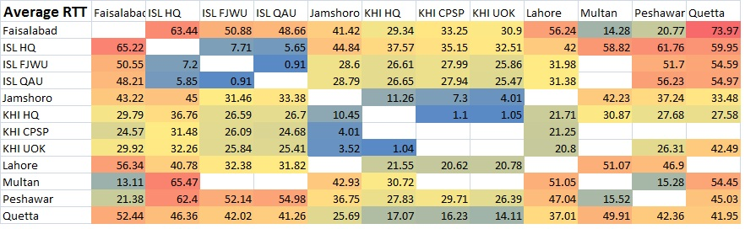

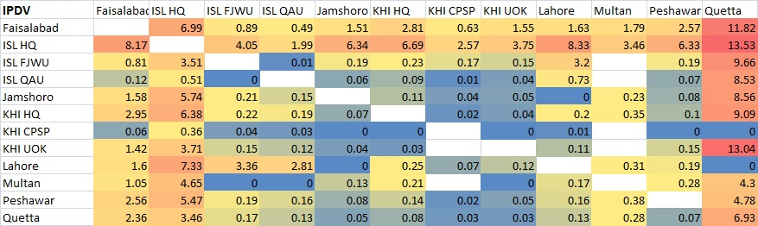

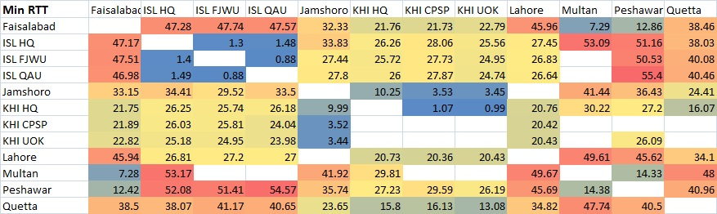

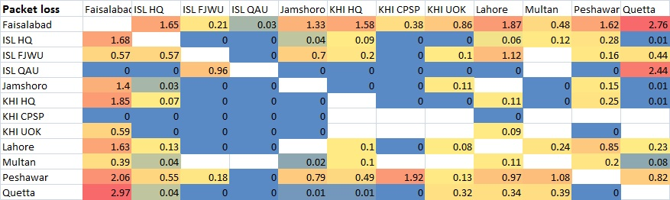

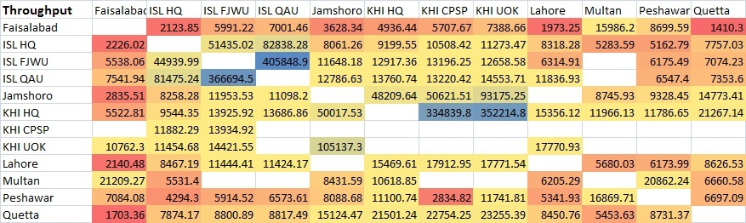

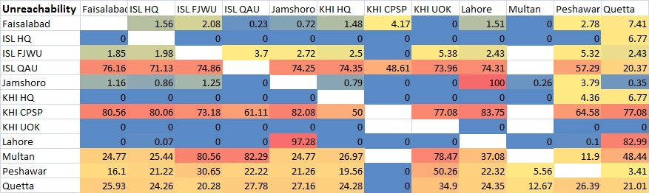

Intra Region PoP performance

In this section we tried to carry out the performance comparison of PoP nodes to the Pern nodes of the same region. We tried to look deeply into the performance of all the three PoPs in Islamabad and Karahi region. In the table below medians of the metric values from the PoPs to their respective regions are compared. The color scale red-grey-blue is used to show the comparative values of each metric (i.e each column is compared with itself and given the color). Red is for bad values and Blue for good values.

 | Unreachability | Average RTT | Minimum RTT | IPDV | Packet Loss | Throughput
ISL HQ | 1.29 | 10.09 | 10.09 | 5.88 | 0.01 | 85676.12
ISL FJWU | 0.28 | 1.385 | 1.385 | 0.335 | 0 | 269545.5
ISL QAU | 0 | 1.34 | 1.34 | 0.38 | 0 | 298327.4
KHI HQ | 44.03 | 16.615 | 16.615 | 0.21 | 1.065 | 33285.96
KHI CPSP | 0 | 14.1 | 14.1 | 0.01 | 0 | 31477.76
KHI UOK | 29.47 | 15.21 | 15.21 | 0.22 | 0.495 | 48321.91
LHR HQ | 1.65 | 1 | 1 | 0.01 | 0.07 | 354665.9
PWR HQ | 17.665 | 12.62 | 12.62 | 0.38 | 0.29 | 226126.2
Quetta HQ | 40.8 | 43.12 | 43.12 | 7.87 | 1.6 | 3830.44

It is clearly observed that Quetta PoP performs worst for its own region with each metric value as bad among all other regions. This is followed by Karachi PoP nodes, then Peshawar and then Islamabad, while Lahore PoP, ISL FJWU and ISL QAU performed best among all.

Inter Region PoP to region Analysis
In this section a comparison of performance of all PoP nodes to all the regions is carried out. The colors in table show the comparative position of each region when accessed from that PoP.
Note: In the tables below columns are the monitoring PoP nodes while the rows are the monitored regions. The color of each cell is chosen in comparison with its own column. That is the first column represents metric values from Faisalabad to other regions with color scale red-grey-blue representing the comparative values with red as bad value and blue as good values.

Ping Unreachability:
The graph below clearly shows that Quetta and Jamshoro PoPs face high unreachability while accessing Lahore region. High unreachability is observed by all the PoPs when accessing Quetta and Karachi region. However; Lahore, Islamabad and Peshawar region had good reachability.
Ping Unreachability (%) | Faisalabad | ISL HQ | ISL FJWU | ISL QAU | Jamshoro | KHI HQ | KHI CPSP | KHI UOK | Lahore | Multan | Peshawar | Quetta
Islamabad | 1.52 | 1.29 | 0.28 | 0 | 1.5 | 1.235 | 0 | 0 | 1.34 | 0 | 3.38 | 0.17
Karachi | 13.065 | 42.325 | 23.265 | 32.75 | 13.835 | 44.03 | 0 | 29.47 | 44.025 | 15.19 | 19.825 | 11.865
Lahore | 1.85 | 2.06 | 1.53 | 0.69 | 97.28 | 1.87 | 0 | 2.86 | 1.65 | 1.56 | 3.47 | 82.99
Peshawar | 20.135 | 19.97 | 6.04 | 2.315 | 15.665 | 19.875 | 0.695 | 3.91 | 18.98 | 3.775 | 17.665 | 4.4
Quetta | 36.235 | 37.89 | 33.125 | 29.69 | 34.585 | 38.32 | 2.085 | 24.61 | 77.01 | 54.375 | 33.415 | 40.8

Round Trip Time
The graph for minimum RTT fails to give us some clear announcement s however looking at the table of values, it is observed that Faisalabad PoP performs worst while accessing Lahore and Islamabad region inspite of the fact that both of these regions are geographically located very close to Faisalabad. Peshawar Region showed High RTT when accessed from almost all the PoPs. Karachi PoPs face lesser RTT as compared to other PoPs. Multan PoP has high RTT to all of the regions except Peshawar.

Min RTT(ms) | Faisalabad | ISL HQ | ISL FJWU | ISL QAU | Jamshoro | KHI HQ | KHI CPSP | KHI UOK | Lahore | Multan | Peshawar | Quetta
Islamabad | 58.22 | 10.09 | 1.385 | 1.34 | 35.08 | 27.43 | 28.25 | 26.45 | 32.01 | 50.51 | 52.275 | 52.675
Karachi | 39.54 | 48.08 | 32.64 | 39.375 | 10.72 | 16.615 | 14.1 | 15.21 | 37.05 | 40.94 | 38.74 | 38.16
Lahore | 57.01 | 40.85 | 32.41 | 32.65 |  | 22.13 | 21.23 | 21.56 | 1 | 52.59 | 48.52
Peshawar | 31.93 | 67.39 | 59.265 | 59.3 | 41.865 | 33.09 | 30.955 | 34.73 | 55.51 | 23.1 | 12.62 | 60.185
Quetta | 47.425 | 49.875 | 42.64 | 41.88 | 24.025 | 17.61 | 16.27 | 17.095 | 35.32 | 47.155 | 42.875 | 43.12

IPDV:

IPDV was highest from Quetta PoP to other regions. Only Lahore region had less IPDV from Quetta PoP. Bad IPDV trend was then followed by Islamabad Headquarter PoP. Islamabad PoP faced high IPDV to all of the regions. Islamabad region had high IPDV from all of the PoP nodes. This is because of heavy traffic at Islamabad region.
IPDV(ms) | Faisalabad | ISL HQ | ISL FJWU | ISL QAU | Jamshoro | KHI HQ | KHI CPSP | KHI UOK | Lahore | Multan | Peshawar | Quetta
Islamabad | 2.87 | 5.88 | 0.335 | 0.38 | 0.48 | 0.295 | 0.2 | 0.395 | 3.44 | 0.68 | 0.58 | 9.8
Karachi | 2.715 | 3.89 | 0.32 | 0.335 | 0.175 | 0.21 | 0.01 | 0.22 | 0.275 | 0.41 | 0.2 | 7.51
Lahore | 2.81 | 7.82 | 3.27 | 2.83 | 0 | 0.22 | 0.05 | 0.09 | 0.01 | 0.48 | 0.16 | 0
Peshawar | 3.23 | 5.875 | 0.375 | 0.795 | 0.215 | 0.255 | 0.065 | 0.23 | 0.34 | 0.65 | 0.38 | 8.415
Quetta | 1.07 | 3.47 | 0.245 | 0.14 | 0.05 | 0.085 | 0.02 | 0.04 | 0.035 | 0.1 | 0.065 | 7.87

Packet Loss:
Quetta region has high Packet losses from all of the PoPs with Multan and Islamabad QAU (Quaid e Azam University PoP node) PoPs giving values of 3.9% and 4.2%. Looking at table below it is observed that Faisalabad PoP has packet losses above 1.5% to all of the regions with highest packet loss of 2.89% for Peshawar region.
Packet Loss (%) | Faisalabad | ISL HQ | ISL FJWU | ISL QAU | Jamshoro | KHI HQ | KHI CPSP | KHI UOK | Lahore | Multan | Peshawar | Quetta
Islamabad | 1.53 | 0.01 | 0 | 0 | 0.1 | 0.12 | 0 | 0.015 | 0.17 | 0.07 | 0.06 | 0.05
Karachi | 2.48 | 1.05 | 0.18 | 1.945 | 0.21 | 1.065 | 0 | 0.495 | 0.815 | 0.88 | 0.89 | 0.98
Lahore | 2.04 | 0.06 | 0.01 | 0 |  | 0.11 | 0 | 0.03 | 0.07 | 0.11 | 0.24 | 0.06
Peshawar | 2.86 | 0.155 | 0.18 | 0.36 | 0.115 | 0.185 | 0 | 0.18 | 0.465 | 0.31 | 0.29 | 0.36
Quetta | 1.73 | 1.5 | 0.245 | 4.24 | 0.34 | 0.925 | 0 | 0 | 0.38 | 3.92 | 1.36 | 1.6

Throughput:
All the regions had throughput above 10Mbps from all PoP nodes except Faisalabad PoP, Quetta PoP and ISL HQ PoP node. Peshawar region had poor throughput from almost all of the PoP nodes as seen in the table. Low throughput is the result of bad RTTs, high packet losses and high IPDVs.

Throughput (Kbps) | Faisalabad | ISL HQ | ISL FJWU | ISL QAU | Jamshoro | KHI HQ | KHI CPSP | KHI UOK | Lahore | Multan | Peshawar | Quetta
Islamabad | 2085.11 | 85676.12 | 269545.5 | 298327.4 | 10585.47 | 12057.1 | 13072.38 | 13538.64 | 10200.55 | 6875.62 | 6892.28 | 2528.06
Karachi | 2449.39 | 6629.74 | 10835.58 | 7497.73 | 50475.97 | 33285.96 | 31477.76 | 48321.91 | 8396.015 | 4738.68 | 6572.87 | 3561.07
Lahore | 1857.19 | 8754.46 | 11228.55 | 10876.95 |  | 15243.38 | 17397.87 | 16360.43 | 354665.9 | 6351.86 | 6550.25
Peshawar | 2969.365 | 4922.84 | 5971.76 | 5479.38 | 7947.26 | 10129.77 | 11932.06 | 10549.19 | 5051.54 | 15623.1 | 226126.2 | 2194.235
Quetta | 3864.915 | 6853.91 | 7764.205 | 6125.335 | 16147.23 | 19665.9 | 22696.17 | 21708.62 | 8183.93 | 4931.885 | 7560.695 | 3830.44

Comparison of performance of all inter region PoP to Region network:
- Quetta and Jamshoro PoPs face high unreachability while accessing Lahore region.
- High unreachability is observed by all the PoPs when accessing Quetta and Karachi region.
- Lahore , Islamabad and Peshawar region had good reachability.
- Faisalabad PoP performs worst while accessing Lahore and Islamabad region inspite of the fact that both of these regions are geographically located very close to Faisalabad.
- Peshawar Region showed High RTT when accessed from almost all the PoPs.
- Karachi PoPs face lesser RTT as compared to other PoPs.
- Multan PoP has high RTT to all of the regions except Peshawar.
- IPDV was highest from Quetta PoP to other regions.
- Islamabad region had high IPDV from all PoPs.
- Only Lahore region had less IPDV from Quetta PoP.
- Bad IPDV was then observed for Islamabad Headquarter PoP. Islamabad PoP faced high IPDV to all of the regions. This is because of heavy traffic at Islamabad PoP node.
- Quetta region has high Packet losses from all of the PoPs with Multan and Islamabad QAU PoPs giving values of 3.9% and 4.2%.
- Faisalabad PoP has packet losses above 1.5% to all of the regions with highest packet loss of 2.89% to Peshawar region.
- Low throughput was observed from Faisalabad PoP, Quetta PoP and ISL HQ PoP node. This low throughput was a result of bad RTT, high packet losses and high IPDVs.
- Peshawar region had poor throughput from almost all of the PoP nodes because of bad RTT.

Outliers
In this section we try to look into a few of the outlier nodes in each of the region. These nodes are the ones which have high RTT, high packet loss and high IPDV.

Outliers in Islamabad region
Airuniversity (AU) and Islamic International University (IIU) were the outliers in Islamabad region with high IPDV, packet loss and average RTT.
We tried to look at the traceroutes of PoP nodes accessing AU. Faisalabad PoP, Multan PoP, Quetta PoP and Peshawar PoP all go through the router rwp44.pie.net.pk (221.120.236.190) which is located in Islamabad and results in high RTT due to high traffic going through it. Below is the traceroute of Peshawar PoP to AU.
Executing exec(traceroute, -m 30 -q 3 -f 3, 111.68.96.101, 140)
traceroute to 111.68.96.101 (111.68.96.101), 30 hops max, 140 byte packets
4 rwp44.pie.net.pk (221.120.253.41) 4.701 ms 5.013 ms 5.004 ms
5 rwp44.pie.net.pk (221.120.254.30) 27.986 ms 27.979 ms 27.971 ms
6 rwp44.pie.net.pk (221.120.251.22) 31.379 ms 31.611 ms 31.603 ms
7 rwp44.pie.net.pk (221.120.236.190) 55.469 ms 221.120.197.154 (221.120.197.154) 59.003 ms 59.228 ms (is in ISL)
8 172.31.240.10 (172.31.240.10) 59.731 ms 59.960 ms 60.191 ms
9 172.31.252.50 (172.31.252.50) 55.754 ms 55.602 ms 55.409 ms

Lahore PoP goes to Karachi first and then to Islamabad. Below is the traceroute confirming this observation.
Executing exec(traceroute, -m 30 -q 3 -f 3, 111.68.96.101, 140)
traceroute to 111.68.96.101 (111.68.96.101), 30 hops max, 140 byte packets
4 tw16-static98.tw1.com (117.20.16.98) 7.495 ms 7.487 ms 7.476 ms (Is in KHI)
5 tw255-static30.tw1.com (110.93.255.30) 11.907 ms 12.224 ms 12.495 ms (is in ISL)
6 tw23-static234.tw1.com (117.20.23.234) 27.481 ms 27.479 ms 27.470 ms (is in KHI)
7 172.31.240.10 (172.31.240.10) 31.079 ms 30.767 ms 30.761 ms (private IP address)
8 172.31.252.50 (172.31.252.50) 27.424 ms 27.420 ms 27.414 ms (private IP address)

Outliers in Karachi region
Institute of Business administration Sukkhar (IBA-SUK), Isra University and Sindh Agriculture University (SAU) were the outliers in the Karachi region. Looking at the traceroutes it is observed that Islamabad Headquarter PoP when accesses IBA-SUK it goes to Karachi, then to Islamabad and then to IBA-SUK. All the traffic going to IBA-SUK goes through the router static.khi77.pie.net.pk (221.120.202.126) which is located in Islamabad. Below is the traceroute for Islamabad Headquarter to IBA-SUK
Executing exec(traceroute, -m 30 -q 3 -f 3, 121.52.157.55, 140)
traceroute to 121.52.157.55 (121.52.157.55), 30 hops max, 140 byte packets
4 172.31.250.57 (172.31.250.57) 27.376 ms 27.441 ms 28.008 ms (private LAN IP)
5 khi77.pie.net.pk (202.125.134.241) 27.196 ms 27.305 ms 27.974 ms (is in KHI)
6 rwp44.pie.net.pk (221.120.251.21) 29.723 ms 29.708 ms rwp44.pie.net.pk (221.120.251.169) 27.255 ms (is in ISL)
7 rwp44.pie.net.pk (221.120.251.82) 46.487 ms 46.472 ms 46.456 ms (is in ISL)
8 static.khi77.pie.net.pk (221.120.202.126) 49.075 ms 49.059 ms 49.326 ms (is in ISL)
9 iba.edu.pk (121.52.157.55) 51.668 ms 58.702 ms 101.614 ms

Outliers in Lahore region
Kinnaird, CEMB, NCA were the outliers. Traffic from other nodes goes to Islamabad, and then to Lahore nodes. It is seen in the traceorute below from Quetta PoP to Kinnaird college.
Executing exec(traceroute, -m 30 -q 3 -f 3, 111.68.105.183, 140)
traceroute to 111.68.105.183 (111.68.105.183), 30 hops max, 140 byte packets
4 rwp44.pie.net.pk (221.120.251.49) 17.438 ms 17.663 ms 17.654 ms(is in ISL)
5 rwp44.pie.net.pk (221.120.251.158) 16.580 ms 16.817 ms 16.807 ms (is in ISL)
6 221.120.197.114 (221.120.197.114) 34.823 ms 35.306 ms 35.296 ms (is in ISL)
7 172.31.240.34 (172.31.240.34) 35.765 ms 35.998 ms 36.237 ms
8 172.31.252.198 (172.31.252.198) 35.500 ms 35.490 ms 35.480 ms
9 kinnaird.edu.pk (111.68.105.183) 35.974 ms 35.693 ms 35.683 ms

Outliers in Peshawar region
Kohat, Hazara University (HU) and College of Aeronautical Engineering (CAE) were the outliers in Peshawar region. The traffic goes through Islamabad routers for a long time before it goes to CAE. This can be seen in the traceroute below from Islamabad Headquarter to CAE.
Executing exec(traceroute, -m 30 -q 3 -f 3, 121.52.144.69, 140)
traceroute to 121.52.144.69 (121.52.144.69), 30 hops max, 140 byte packets
4 172.31.250.57 (172.31.250.57) 29.037 ms 29.091 ms 29.072 ms
5 khi77.pie.net.pk (221.120.205.97) 45.780 ms 45.783 ms 46.248 ms (is in ISL)
6 rwp44.pie.net.pk (221.120.251.21) 30.193 ms rwp44.pie.net.pk (221.120.251.169) 29.084 ms 29.069 ms (is in ISL)
7 rwp44.pie.net.pk (221.120.254.29) 51.262 ms 51.246 ms 54.882 ms (is in ISL)
8 rwp44.pie.net.pk (202.125.148.133) 76.907 ms 69.684 ms 60.698 ms (is in ISL)
9 a8-0-0-223.khi77gw2.pie.net.pk (202.125.159.74) 153.684 ms 52.570 ms 54.286 ms (is in ISL)
10 rwp44.pie.net.pk (221.120.237.194) 127.828 ms rwp44.pie.net.pk (221.120.235.182) 93.799 ms rwp44.pie.net.pk (221.120.237.194) 130.017 ms (is in ISL)
11 * * *
12 * * *

Outliers in Quetta region
Quetta University of Engineering Sciences and Technology (QUEST) is an outlier. The data goes to Islamabad, then to Karachi and then to Quetta. Even if we try to access the QUEST from Quetta PoP, it goes to Islambad then Karachi and then to Quest. In some of the times it faced a loop at Islamabad routers . This can be seen in the traceroute below.
Traceroute from Multan to Quest:
Executing exec(traceroute, -m 30 -q 3 -f 3, 121.52.154.185, 140)
traceroute to 121.52.154.185 (121.52.154.185), 30 hops max, 140 byte packets
4 khi275-P01-pie.net.pk (221.120.254.22) 34.124 ms 34.077 ms 34.064 ms (is in ISL)
5 static-khi275-P02-pie.net.pk (221.120.254.54) 30.558 ms 30.547 ms 30.536 ms (is in ISL)
6 rwp44.pie.net.pk (221.120.251.162) 35.154 ms 35.143 ms 35.132 ms (is in ISL)
7 static-10GE-KHI494-P01-KHI494-SWB.pie.net.pk (202.125.128.157) 41.012 ms 41.032 ms 41.022 ms (is in KHI)
8 rwp44.pie.net.pk (221.120.251.162) 41.263 ms 41.288 ms 41.305 ms
9 static-10GE-KHI494-P01-KHI494-SWB.pie.net.pk (202.125.128.157) 46.377 ms 46.530 ms 46.509 ms
10 rwp44.pie.net.pk (221.120.251.162) 48.016 ms 47.456 ms 47.756 ms
11 static-10GE-KHI494-P01-KHI494-SWB.pie.net.pk (202.125.128.157) 52.788 ms 52.838 ms 52.822 ms
12 rwp44.pie.net.pk (221.120.251.162) 54.102 ms 54.332 ms 54.444 ms
13 static-10GE-KHI494-P01-KHI494-SWB.pie.net.pk (202.125.128.157) 59.407 ms 59.391 ms 59.375 ms

Faisalabad PoP
It is observed that Faisalabad PoP node faced high RTTs and packet losses which resulted in low throughput. Looking into the traceroutes, it was observed that data goes through Islamabad region before reaching Faisalabad and after leaving Faislabad PoP. When Islamabad region is pinged from Faisalabad PoP, it goes through a router named as “ rwp44.pie.net.pk (221.120.236.190) “ which on average takes 56ms reaching this router. Also loops are observed in traceroutes from Faisalabad PoP to other nodes. One of the traceroutes from Faisalabad PoP to University of Arid Agriculture Rawalpindi (UAAR) is shown below for reference.
Executing exec(traceroute, -m 30 -q 3 -f 3, 111.68.99.248, 140)
traceroute to 111.68.99.248 (111.68.99.248), 30 hops max, 140 byte packets
4 rwp44.pie.net.pk (221.120.254.42) 34.045 ms 34.009 ms 33.997 ms (is in ISL)
5 rwp44.pie.net.pk (221.120.251.22) 24.114 ms 24.136 ms 24.228 ms
6 rwp44.pie.net.pk (221.120.236.190) 61.803 ms 61.925 ms 221.120.197.154 (221.120.197.154) 61.718 ms (is in ISL)
7 172.31.252.30 (172.31.252.30) 61.831 ms 61.842 ms 61.877 ms (is a private IP)
8 111.68.99.248.uaar.edu.pk (111.68.99.248) 69.881 ms 69.868 ms 69.853 ms
9 111.68.99.248.uaar.edu.pk (111.68.99.248) 70.548 ms 70.234 ms 70.484 ms
10 111.68.99.248.uaar.edu.pk (111.68.99.248) 70.165 ms 72.265 ms 70.851 ms

Conclusion
The traceroutes show that routing all of the traffic of all the regions through Islamabad routers is a main cause of high RTTs, high IPDVs and high packet losses; all of which result in low throughput. Also, unreachability is a major issue which is mostly due to power outages. In some traceroutes looping between the routers at Islamabad region is also observed. Inter-region pern networks can improve the network performance between the cities.

